Cultivating Resilience from the Inside Out:
Developing a Yes Brain in Children and Adolescents
Presentation by Dr. Dan Siegel
Thursday, January 11th, 2018
3rd Period: 10:05 - 11:05 A.M. MVHS Theater

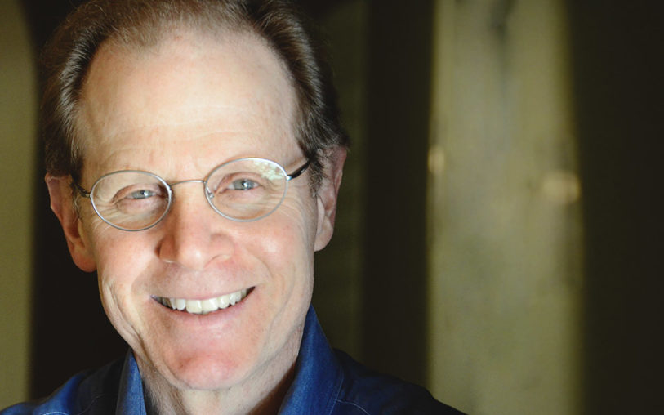

Childhood and adolescence are essential parts of our development and our evolution—and a growth-mindset can cultivate resilience and well-being in youth. On January 11th, 2018, Dr. Siegel will host a presentation in the Spartan Theater during 3rd Period from 10:05 AM - 11:05 AM. Dr. Siegel will be exploring the nature of the changes in the developing brain and how they set the stage for childhood and adolescent mental, physical, and interpersonal well-being. A “Yes-Brain” refers to how we can support the receptive state of brain activation within our families and schools.

If you wish to attend, please complete the following information and turn in this permission slip to the Activities Office by Monday, January 8th, at 3:30 PM. Space is limited and will be assigned on a first-come, first-served basis. Because the presentation is during school hours, we request that attending students inform their 3rd teachers that they will be missing.

----------------------------------------------------------------------------------------------------------

Student Name _______________________________ Student Number ___________

3rd period teacher’s signature: ____________________________________________

